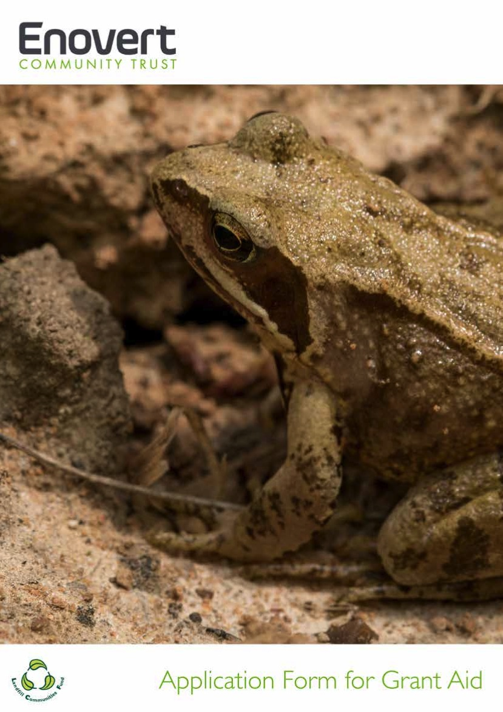

YES / NO

YES / NO
YES / NO
YES / NO
YES / NO
YES / NO
YES / NO
YES / NO
YES / NO
YES / NO
YES / NO
YES / NO
YES / NO

YES / NO
YES / NO
YES / NO
YES / NO
YES / NO
YES / NO
YES / NO
YES / NO
YES / NO

